COSC2100

Robert Macklem

100955944

February 16, 2025

*ICE 5 Report*

Here is a screenshot of my running Windows Forms App as soon as it launches:

Here is a screenshot of my running game after 2 requirements have been met:

Here is a screenshot of my running game after 2 requirements have been found and password is hidden:

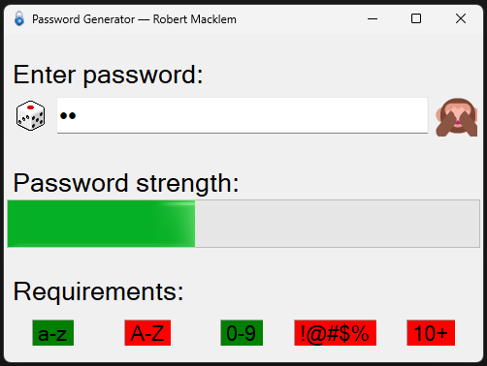

And here is the GUI after a password has been generated, and password is shown:

**Question 1:** What are **Collections** in C#?

**Answer:** Collections are a data type that store multiple numbers of other data types. For example, a collection of integers is a structure that contains multiple integers accessible by indices.

**Question 2:** In C#, why can we use **square brackets** **[]** to access **specific letters** in a **string**?

**Answer:** Because square brackets access a specific index of an array, and a string is an array of characters (char[]).